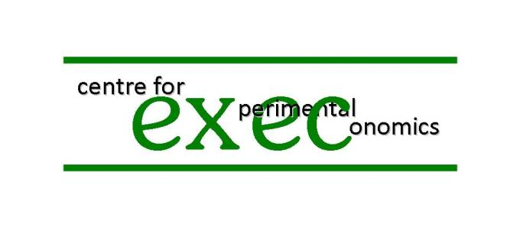
Welcome to this experiment. Thank you for coming. These Instructions are to help you to understand what you are being asked to do during the experiment, and how you can earn money from it. This will be paid to you in cash after you have completed the experiment.
In this experiment there is no participation fee – what you earn in the experiment is what you will be paid.
Please do not talk with others for the duration of the experiment. If you have a question please raise your hand and one of the experimenters will answer your question in private. Please turn off your mobile phone.

What the experiment involves
The experiment involves trading, with the other 11 participants in this experimental session, assets for tokens. It is a market experiment.

The experiment as a whole
The experiment consists of a number of sequences, each of which is divided into a number of periods. The number of periods in a sequence is random and hence the number of sequences is random. In all periods the market will be open and you can trade.

Assets and Tokens
The experiment involves assets and tokens. Assets carry over from period to period within each sequence; tokens do not. Within a period you can use tokens for buying and selling assets.

Assets in each sequence
At the beginning of each sequence you will be endowed with a certain number of units of the asset, but you will receive no more units during that sequence; you can change the number of units only by trading with other participants in this experiment. Assets pay a dividend of 2 tokens per period.

Tokens in each period and each sequence
In each period within a sequence you will be endowed with a certain number of tokens – they can be used for buying the asset, and the number you have can be increased by selling the asset. This token endowment will vary from period to period. The token endowment will go in a cycle of length 3 in each sequence, with the endowments varying from subject to subject. Specifically, the token endowment will be 109, 53, 67, 109, 53, 67, and so on, for four subjects; will be 49, 113, 45, 49, 113, 45, and so on, for four other subjects; and 59, 51, 105, 59, 51, 105, and so on, for four others. This is to make trading mutually beneficial.

How you will be paid
As explained, you will be endowed with a certain number of tokens at the beginning of every period. You can trade throughout a period and hence increase or decrease your stock of tokens (while at the same time decreasing or increasing your holding of the asset). Your payment for any one period will be determined by your end-of-period tokens holding. Please consult the Table and the Figure at the end of these Instructions; examine whichever you find most convenient. For example, an end-of-period tokens holding of 79 implies a payment of £1. Do note that if your end-of-period tokens holding is less than 65 your payment for that period will be negative. Negative payments will be offset against positive payments. Also note that the payment from each additional token that you hold at the end of a period is diminishing; for example, the payment difference between 105 and 106 end-of-period tokens is smaller than the difference between 79 and 80 end-of-period tokens. To protect you against any large losses, the software will not allow you to trade in such a way that your token balance falls below 45 at any time. Your payment for the experiment as a whole will be the sum of the payments over all the periods for which the experimental session has lasted.

How long each period of trading lasts
Each period lasts 3 minutes.

The number of periods within a sequence
As already noted the number of periods in a sequence is random. At the end of every period one of the participants will roll a die (with sides numbered from 1-6). If the number rolled is 1 to 5, the sequence will continue with a new 3-minute period. If a 6 is rolled, the sequence will end.

How long the experiment will last
If less than one hour has passed since the start of the first sequence, a new sequence will begin. If more than one hour has elapsed since the beginning of the first sequence then the current sequence will be the last sequence played; that is, the next time a 6 is rolled the sequence will end and the experiment will be over. In the unlikely event that more than two hours have elapsed since the beginning of the first sequence, or more than one hour has elapsed since the beginning of the current sequence, then we will simply stop the experiment that day; if the experiment is paused this way, you will be invited to continue and finish that sequence at a later date. Whatever the outcome of the random processes, you will be in this laboratory today for at most two-and-a-half hours (including reading these Instructions and watching a short video).

Rules for trading the asset
Trading involves setting a price at which you want to buy or sell and the quantity of units of the asset that you want to buy or sell. The way you do this is described in the video that you will watch after all have read these Instructions. The experiment will start with a practice period, which will not count towards your payment.

Why you might want to trade assets in the asset market
Trading the asset enables you to vary your end-of-periods tokens, but remember that if you sell you will lose 2 tokens (the dividend) per unit that you sell.

Summary and Conclusions
This experiment is about trading an asset which pays a dividend. You might want to buy the asset if you have too many tokens or want to increase your dividend income; you might want to sell it if you have too few tokens and do not mind your dividend income falling. But all depends upon the price of the asset. This is determined within the experiment by the decisions of all the participants. You are one of them. Thank you for participating.

Enrica Carbone
John Hey
Tibor Neugebauer

January 2020
Figure: Payment Schedule
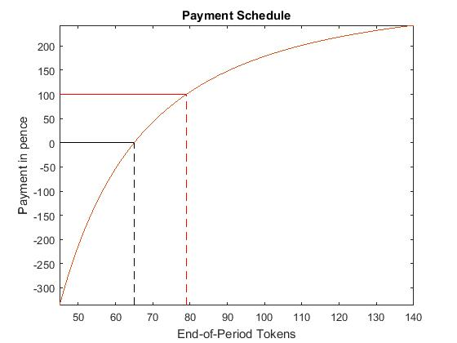

Table: Payment Schedule
End-of-period tokens | Payment in pence | End-of-period tokens | Payment in pence | End-of-period tokens | Payment in pence | End-of-period tokens | Payment in pence
45 | -336 | 69 | 35 | 93 | 158 | 117 | 214
46 | -309 | 70 | 43 | 94 | 162 | 118 | 216
47 | -283 | 71 | 50 | 95 | 165 | 119 | 217
48 | -258 | 72 | 57 | 96 | 168 | 120 | 219
49 | -235 | 73 | 64 | 97 | 171 | 121 | 220
50 | -214 | 74 | 71 | 98 | 173 | 122 | 222
51 | -193 | 75 | 77 | 99 | 176 | 123 | 223
52 | -174 | 76 | 83 | 100 | 179 | 124 | 225
53 | -156 | 77 | 89 | 101 | 181 | 125 | 226
54 | -139 | 78 | 95 | 102 | 184 | 126 | 227
55 | -123 | 79 | 100 | 103 | 186 | 127 | 228
56 | -108 | 80 | 105 | 104 | 189 | 128 | 230
57 | -93 | 81 | 110 | 105 | 191 | 129 | 231
58 | -79 | 82 | 115 | 106 | 193 | 130 | 232
59 | -66 | 83 | 120 | 107 | 195 | 131 | 233
60 | -54 | 84 | 124 | 108 | 197 | 132 | 235
61 | -42 | 85 | 129 | 109 | 199 | 133 | 236
62 | -31 | 86 | 133 | 110 | 201 | 134 | 237
63 | -20 | 87 | 137 | 111 | 203 | 135 | 238
64 | -10 | 88 | 141 | 112 | 205 | 136 | 239
65 | 0 | 89 | 144 | 113 | 207 | 137 | 240
66 | 9 | 90 | 148 | 114 | 209 | 138 | 241
67 | 18 | 91 | 152 | 115 | 211 | 130 | 242
68 | 27 | 92 | 155 | 116 | 212 | 140 | 243

